STUDENT ID : Cse25-410
STUDENT NAME: ATANG LEFA MMEMO
STUDENT EMAIL : Cse25-410@thuto.bac.ac.bw
ASSIGNMENT TITTLE : WEB MULTI-MEDIA DEVELOPMENT
DATE OF SUBMISSION : 20 May 2026
PROGRAM OF STUDY : COMP[UTER SYSTEMS ENGINEERING
YEAR OF STUDY : 2026

WEBSITE PLANNING AND DOCUMENTATION
SPOTLESS RIDE CAR WASH
1)Website Objective and Business Goals
Spotless Ride Car wash is a dedicated and professional car wash and revamping business sorely based in the capital city of Botswana of which is Gaborone .The main role behind the creation of this website is to act as the official digital footprint or presence enabling most probably the customers to discover the brand, see the services available at the company, view what is to be expected from the company and most importantly for them to actually book an appointment online without the means of physical interactions
between the company and the potential customer.
Business goals
i) Generate online bookings for the car wash services .
ii)Provide easily accessible information to potential customers all the time.
iii)Grow the business and reach new geographical areas outside Gaborone.
iv)Build and grow the reputation or trustworthiness of the company by using testimonies from past customers who are satisfied.
Our website objective statement
“To design and develop a modern ,responsive and visually appealing website for a carwash that clearly showcases its services, enhances customer trust and drives customer engagement by providing seamless and user-friendly online booking and services experience “.
1(b)Target Audience
To really know your target audience when developing a website is a crucial part in making it a success ,as it sets the content tone across the whole website ,layout decisions functionality and technical choices such as mobile responsiveness .Spotless Ride’s main target audience is broad from young to old urban Batswana and including large scale to small scale organisations ,the primary audience is young and old Batswana who love the luxury of actually going with clean and refreshing cars .The second target market is organisations who own vehicles that are used to run their organisations but lack the time and resources to wash them.
Demographic and Technical Profile
Demographic Factor | Primary Audience | Secondary Audience
Age Range | 18 -60 | 25-60
Location | Gaborone, Francistown ,Jwaneng | Other urban centres in Botswana
Gender | All genders | All genders
Income Level | Low to middle income ( BWP 2,000-8000/month) | Middle to high income
Car Wash Interest | Car wash vacuum, whole car wash ,carpet wash and tire wash | Car wash vacuum, whole car wash ,carpet wash and tire wash
Tech Aptitude | Moderate to High -daily smartphone users | High – Highly confident with web browsing
Internet Access | Mobile first ( data bundles ,WI-FI hotspots) | Desktop/laptop + mobile
Social Media | Active on TikTok,Instagram,Facebook | Facebook and WhatsApp Business
Occupation | Students, young professionals and older professionals and car enthusiasts | Working professionals and executives and even government officials
Technical Aptitude Implications for Design
Based on the audience profile given above , the following design decisions were made :
I) Performance : Fast loading pages with optimised images are essential for users who may be on mobile data .
ii)Simplicity : Navigation must be simple and intuitive -no more than 3 clicks to reach any page ( the 3 click rule).
iii)Accessible Forms :Forms should use clear labels, minimal required fields and provide helpful error messages for users who may be less digitally confident .
iv)Clear CTAs : Clear call -to-action buttons ( e.g. “Book Now”, “View Services”)guide users who are not used to searching for information on website.
v) Mobile First : The website will be designed mobile-first, as the majority of the target audience have accsess to the internet via smartphone.

Type of Website and Content.
The Spotless Ride Website falls under the category of a small Business Service Website . The classification is based on the main purpose ,content type and intended functionality of the website, as defined in Web development literature ( Niederest Robbins , 2018-Learning Web Design).
Website Classification
Website Type : Small Business /Services Website – the website serves as the digital storefront for Spotless Ride, promoting its services and enabling customer interaction.
Content Type : Informational and interactive – Static Content ( about , services, gallery) combined with an interactive booking form and dynamic navigation.
Functionality :Brochure-style with lead generation features : service listings , pricing ,photo gallery , booking/contact form ,and call to action buttons.
Design Approach : Mobile-first responsiveness design using HTML5,CSS3,Boostrap 5, and JavaScript to ensure accessibility across all device types.
Primary Purpose : To attract potential customers, communicate Spotless Ride’s value proposition and convert website visitors into paying loyal customers.
Content Strategy
The website will contain the following types of content across its pages :
• Homepage (index.html) — A visually engaging hero section highlighting the brand slogan, a summary of services offered, a simple “how it works” process, and customer reviews to build trust.
• Services & Pricing (services.html) — A detailed breakdown of car wash packages, pricing categories based on vehicle type, special bundle offers, and a frequently asked questions (FAQ) section.
• Gallery (gallery.html) — A collection of before-and-after images along with a filterable gallery showcasing completed car wash jobs and results.
• About Us (about.html) — Information about the company’s background, mission, team members, core values, and notable achievements or statistics.
• Contact & Booking (contact.html) — A user-friendly booking form with built-in validation, allowing customers to select services, choose preferred dates, and receive confirmation feedback.
Hierarchical Structure:
Homepage
├── Index
│ ├── Types of car wash service
│ ├── Contact
│ └── Cars
├── Services
│ ├── Feedback
│ ├── Add to Cart
│ └──
└── Social Media Links
4. Technical Brief:
Technologies Used:
- HTML5: The core markup language for structuring the content of the website.
- CSS3: For styling the website, including layout, colors, typography, and responsiveness.
- JavaScript (ES6+): For interactive elements, dynamic content loading (e.g., cart functionality), and client-side logic.
- Bootstrap 5.2.3: A popular open-source CSS framework that provides pre-built components (navbar, cards, modals, grid system) and utility classes for rapid and responsive web development. This significantly reduces development time and ensures a consistent, mobile-first design.
Other Resources (Software Tools, Graphics Tools, etc.):
- Code Editor: Visual Studio Code (VS Code) - Chosen for its extensive features, extensions, integrated terminal, and strong support for web development.

- Hosting Platform: GitHub Pages - Used for free static website hosting, directly integrated with Git repositories.
- Browser Developer Tools: Chrome Developer Tools, Firefox Developer Tools - Crucial for debugging, inspecting elements, testing responsiveness, and performance analysis during development.
Justification for Website Type Selection
A service-based website is the most suitable option for this car wash business at its current stage. While incorporating e-commerce features such as online payments was considered, it has been excluded from Version 1.0 since the service typically requires customers to bring their vehicles on-site. This feature can be explored in future updates once options like mobile car wash or pickup and delivery services are introduced. For now, the primary goal is to increase brand visibility, inform potential customers, and generate leads through the online booking system.

PAGE TEMPLATE DESIGNS FOR SPOTLESS RIDE CARWASH.
HOME PAGE TEMPLATE
CONTACT
ABOUT US
SERVICES
Home
GALLERY
LOGO(Spotless Ride Car Wash

A BIG IMAGE OF A CAR BEIGN WASHED
“Keep your ride spotless”
Book Now Button

ABOUT US PREVIEW
Short intro about Spotless Ride
SERVICES PREVIEW
. Interior Wash . Exterior Wash
. Full Car Wash
CUSTOMER TESTIMONIALS
“Best Car Wash ever”
FOOTER
Contact Location Social Media
SERVICES PAGE TEMPLATE
LOGO Navigation Menu
PAGE TITTLE Our Services
SERVICE 1(price +description) Basic Wash
SERVICE 2 (price + description) Premium Wash
SERVICES 3 (price + description) Full Detailing
SPECIAL OFFERS / PACKAGES
Book Now Button
FOOTER
GALLERY PAGE TEMPLATE
LOGO Navigation Menu
PAGE TITTLE Our Work
IMAGE GRID ( Before and After Photos)
[image] [image] [image]
[image] [image] [image]
FOOTER
ABOUT US PAGE TEMPLATE
LOGO Navigation Menu
PAGE TITTLE About Spotless Ride
IMAGE (Team or Car Wash Location)
ABOUT TEXT
Who are we, mission, values
WHY CHOOSE US
. Quality Service
. Affordable Prices
. Trusted Team
FOOTER

CONTACT PAGE TEMPLATE
LOGO Navigation Menu
PAGE TITTLE Contact Us
CONTACT FORM
Name Email Location
HIGH FEDILITY PAGE TEMPLATE
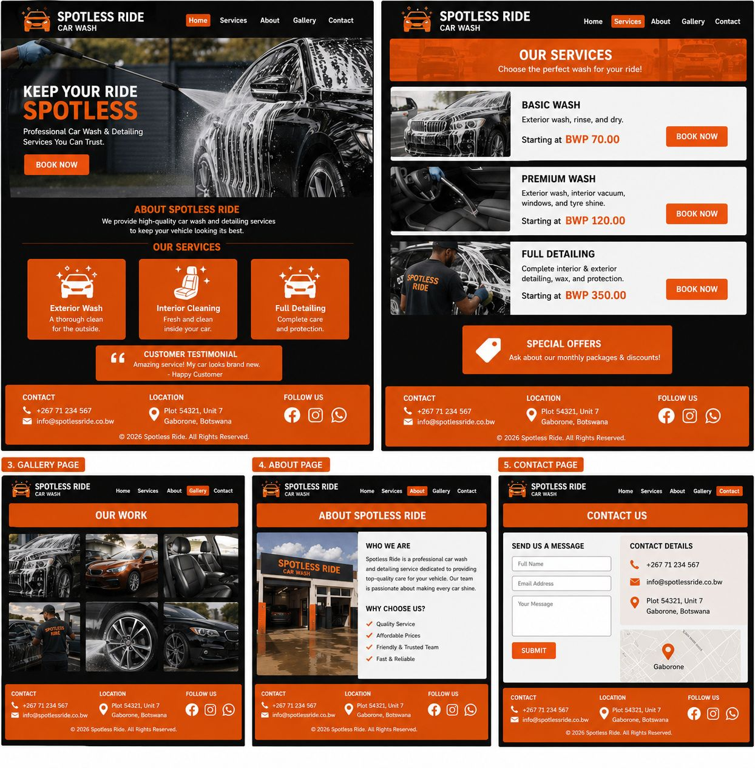
DEVELOPMENT TOOLS
1)Github: This is what I used to host my website and share repository
2)Visual Studio Code : An editor where I wrote the code for web development
GRAPHIC AND DESIGN TOOLS
1) Adobe Photoshop : For creating image editing and graphic design
QUALITY ASSURANCE
COMPUTER COMPATIBILITY
HOME PAGE
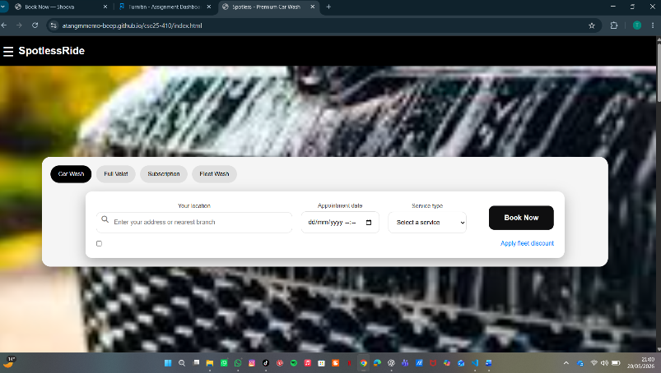 KIK
GALLERY PAGE
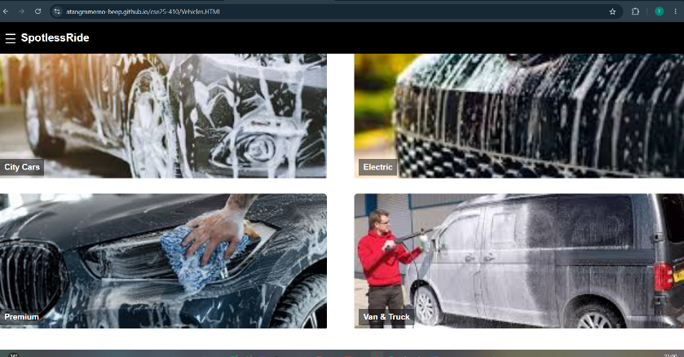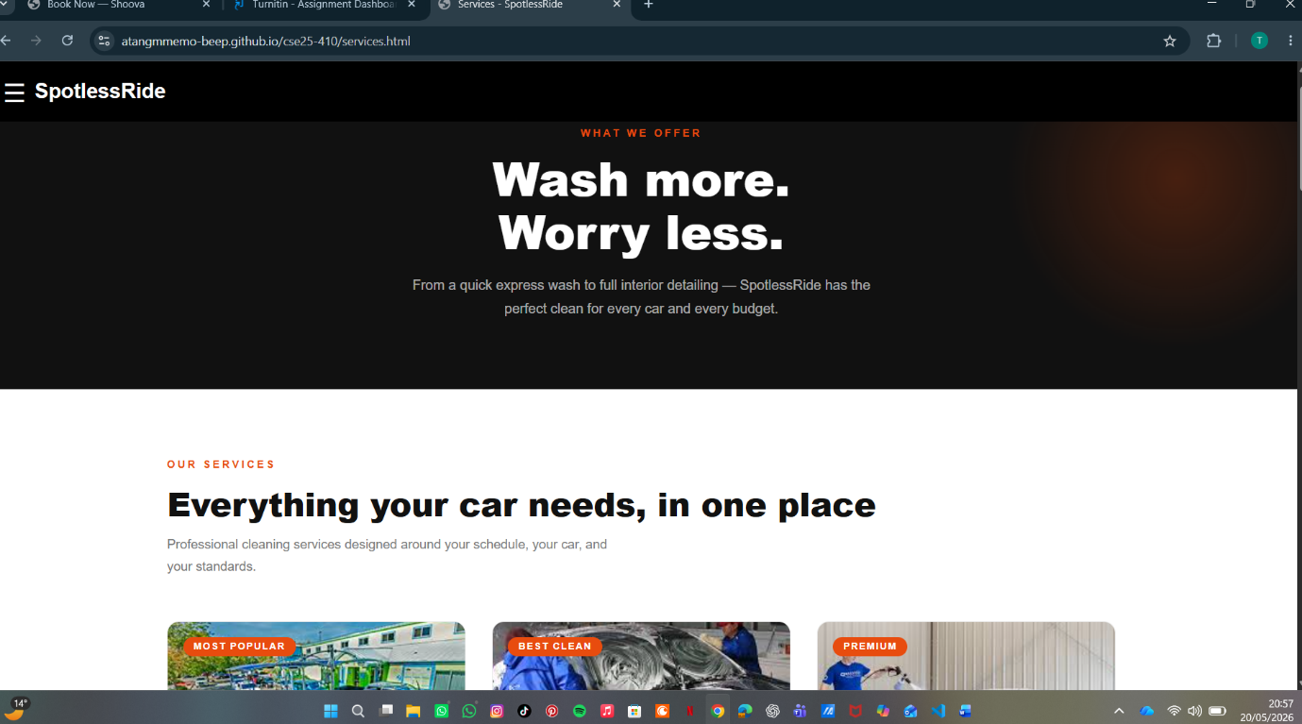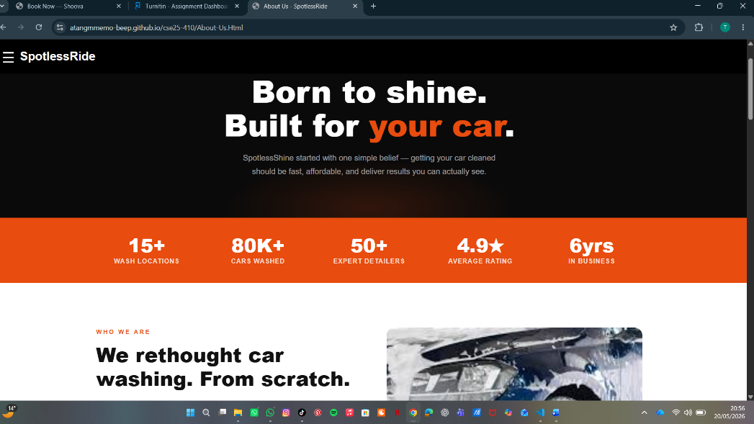

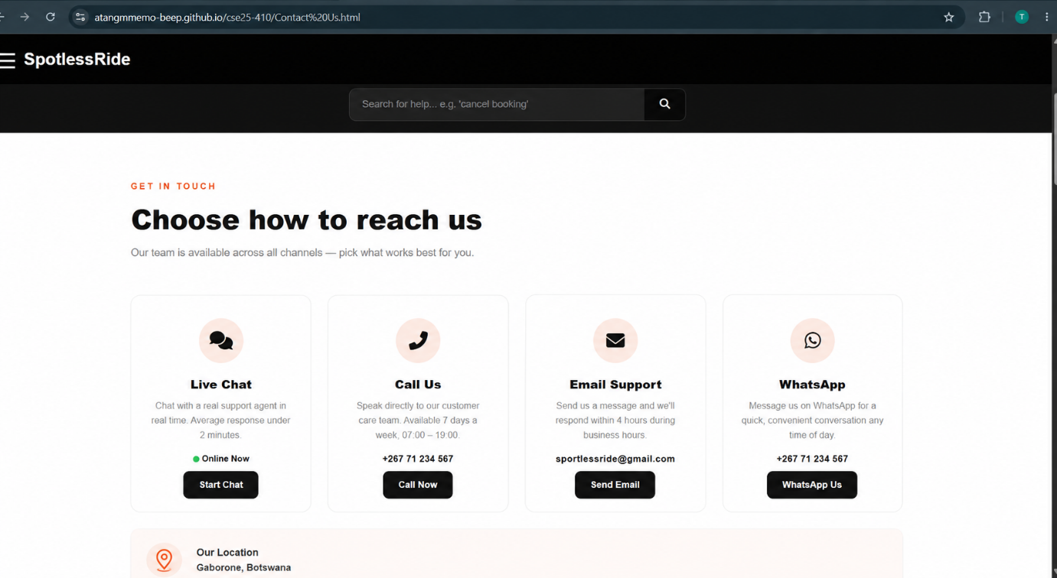
2)MOBILE DEVICE COMPATIBILITY
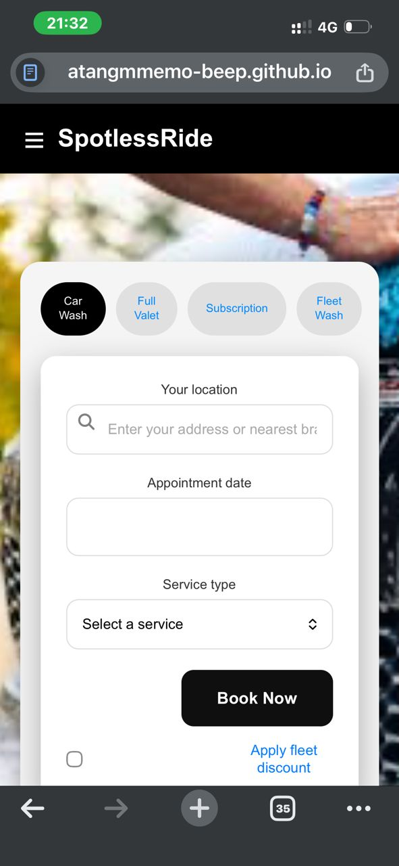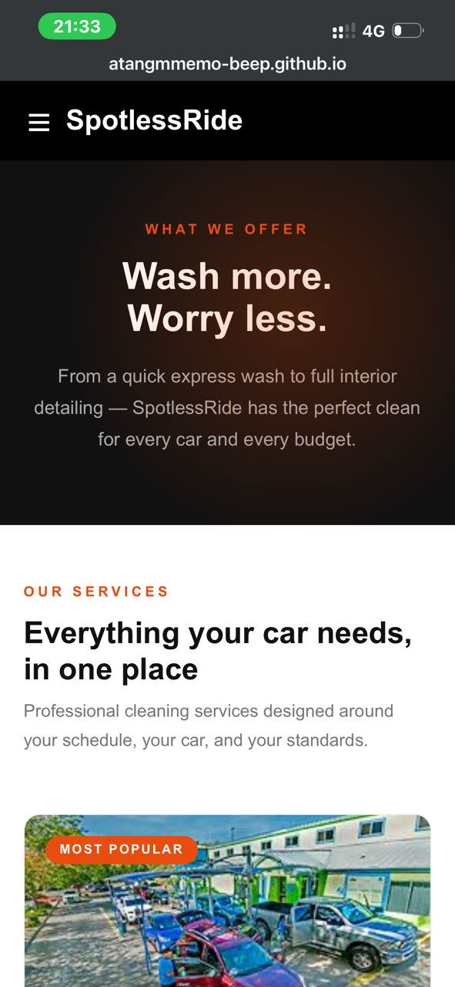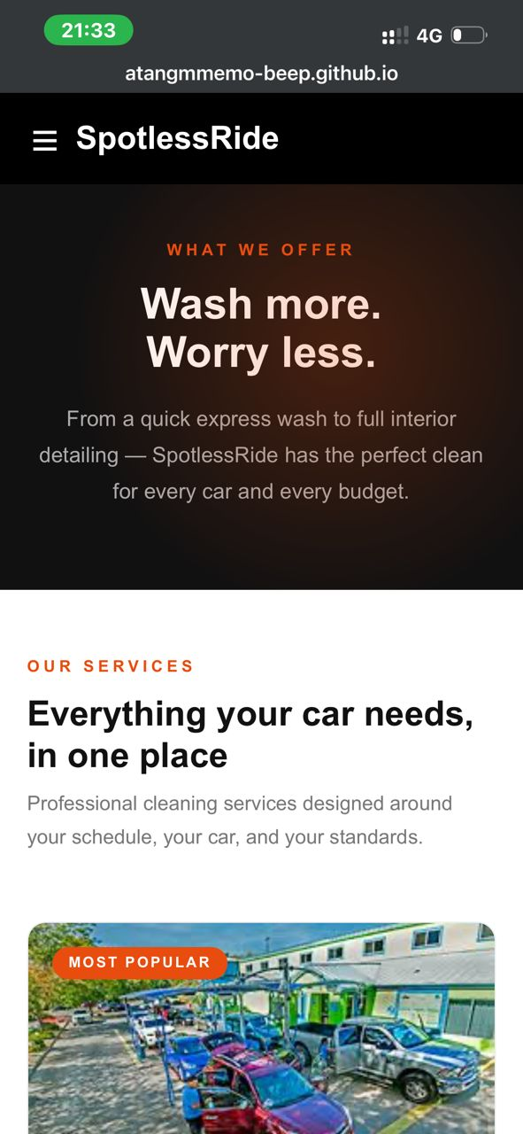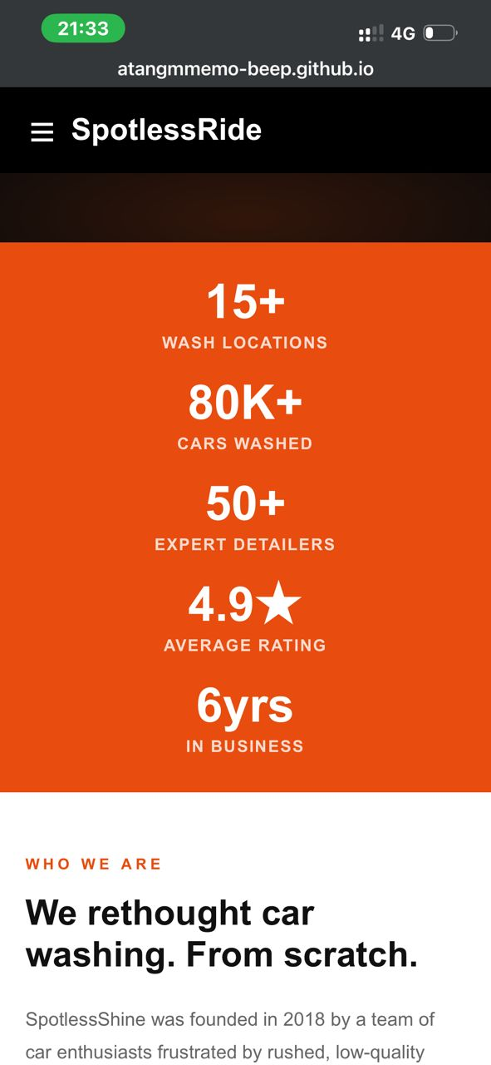
- PUBLISHING AND PROMOION
1)Repository creation
*Log in to Github to actually access it
*Crerate a new new repository
*Ensure the repository is public so it is accessible to everyone

b) Preparation of Website Files
- Add an index.html file (entry point of the website)
- Included other assets like CSS, JavaScript and images and bootstrap

C) Enable GitHub Pages
- Opened repository on GitHub
- Clicked Settings
- Under branch, selected main
- Clicked saved GitHub now hosts the website at https://atangmmemo-beep.io/cse25-410/

Tools Used:
- Git
- GitHub Pages

7. Future developments/Recommendations
- Add smooth in transictions
- Optimize website speed
- Add interactive features such as live chat support for real-time assistance.

Below is the link for the website:
https://github.com/atangmmemo-beep/cse25-410
https://atangmmemo-beep.github.io/cse25-410/

